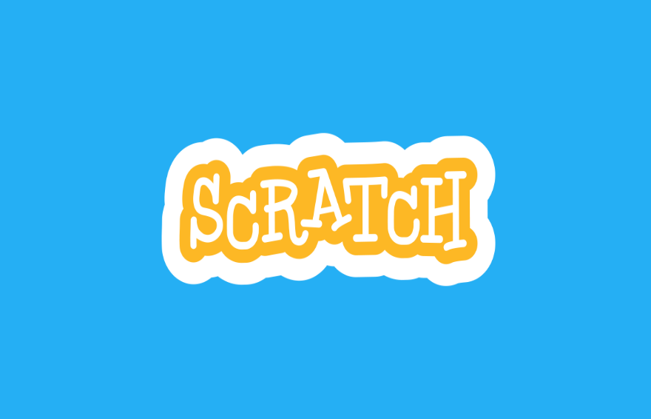

Scratch Project

ITC LAB

Wali Muhammad | 2021-SE-39 | 24-Febraury-2022

# Space Shooter

Description:

The Scratch Project is based on a game named “Space Shooter”, In which a Spaceship is on its journey while it is facing hurdles of Astronomers and Planets. It shoots them by laser to tear them up. If the space touches with any Astronomers or Planet the game will over.

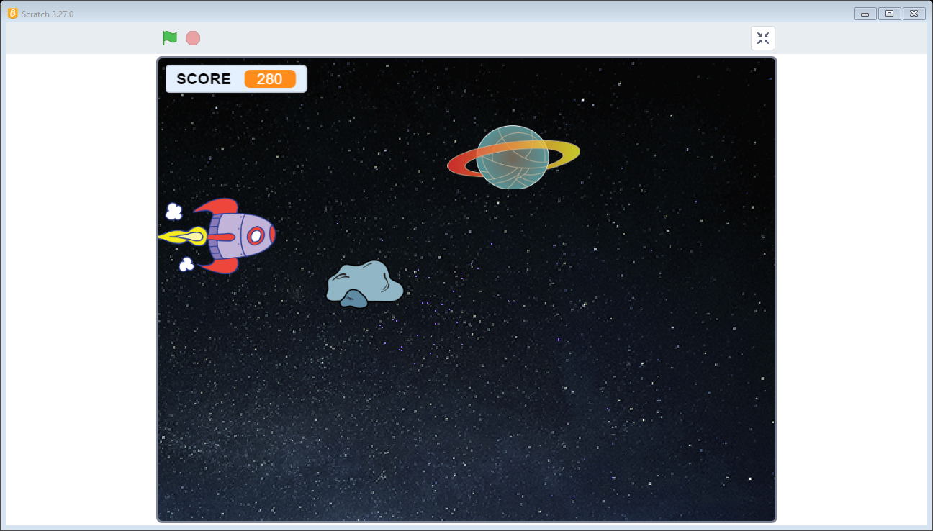

## Structure

The Project is divided on following structure:

* **Sprite**
* **Background**
* **Code**
* **Sprite**

A sprite is the object which is controlled to perform functions. There are 5 sprites used in this Project. They are given below:

* **Spaceship**
* **Rocks**
* **Planet**
* **Laser**
* **Game Over**

The details of these sprits are given below:

* Spaceship

Spaceship is the first sprite used in Scratch Project. The Picture of Sprite is below:

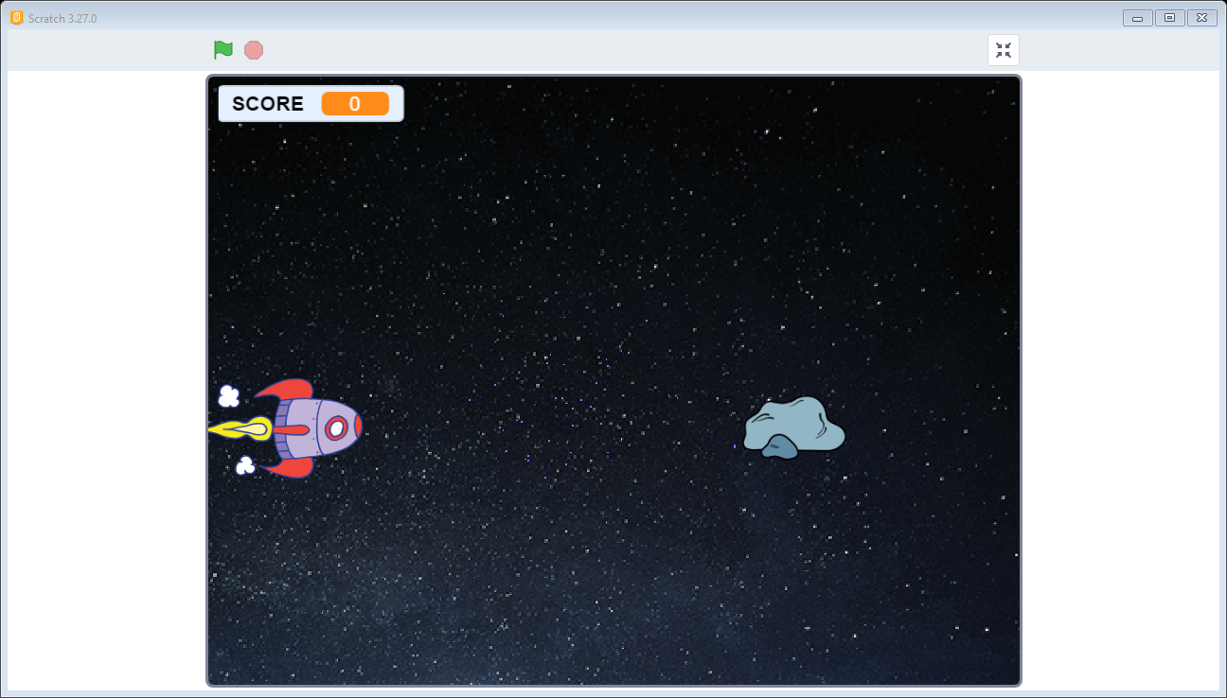

It has 5 Costumes which is shown at the startup in the game.

1.

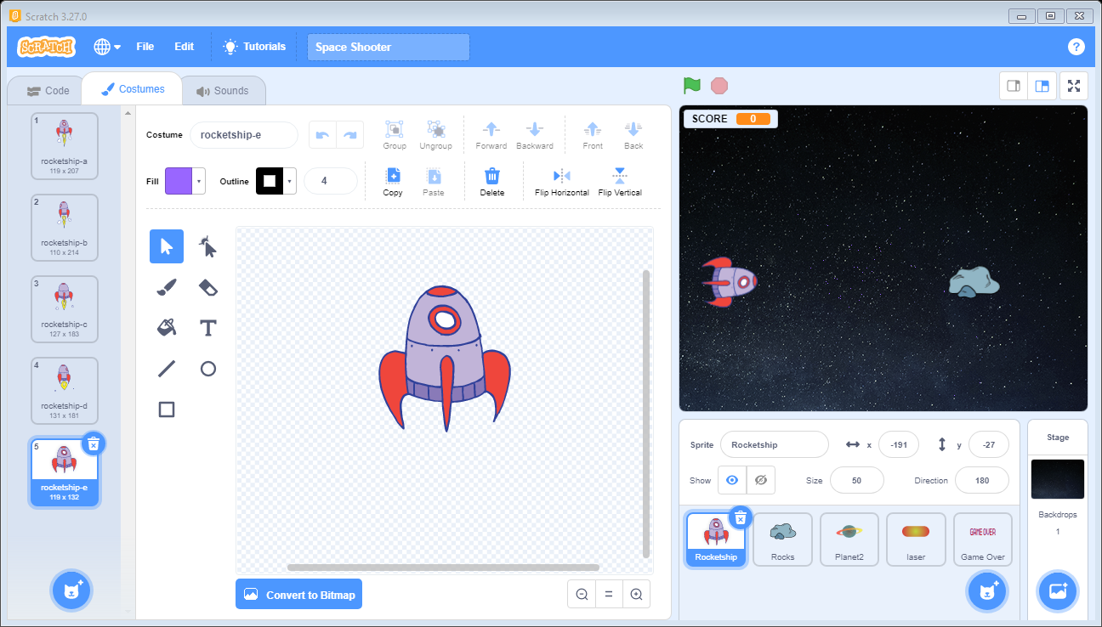

2. 3.

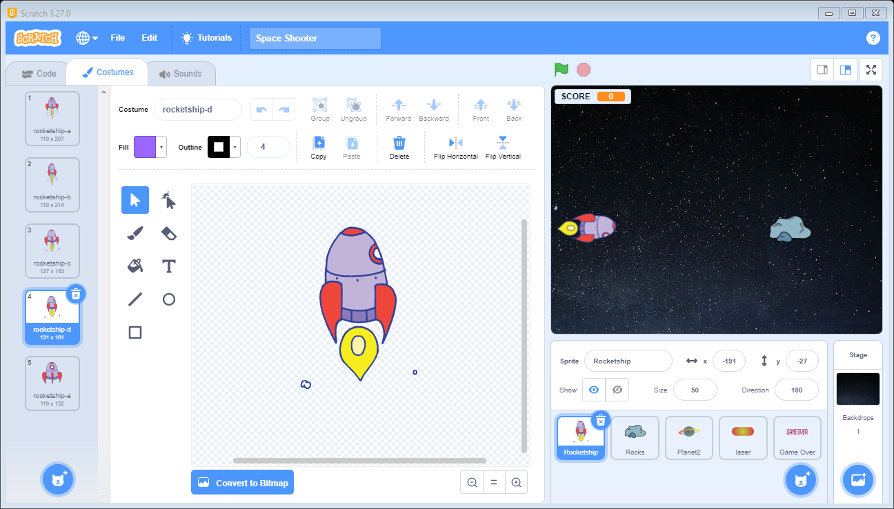 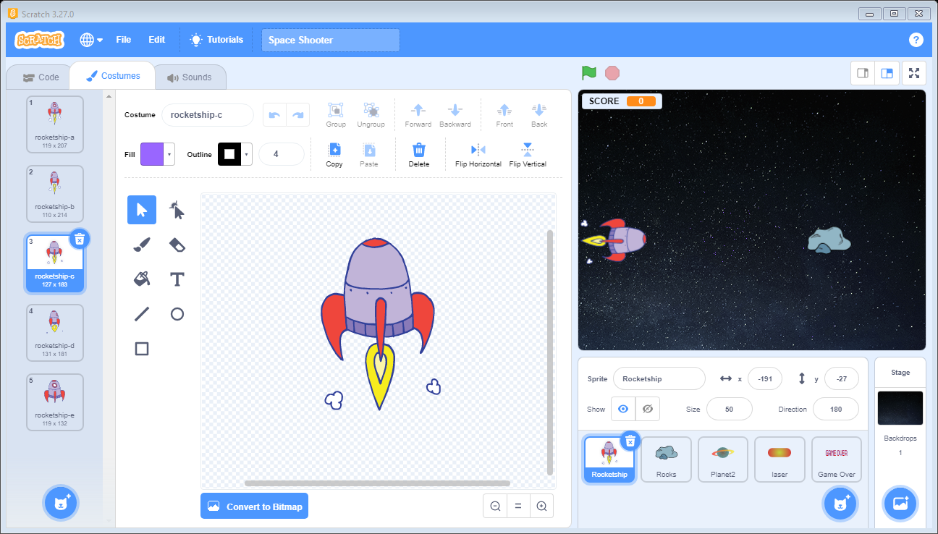

4. 5.

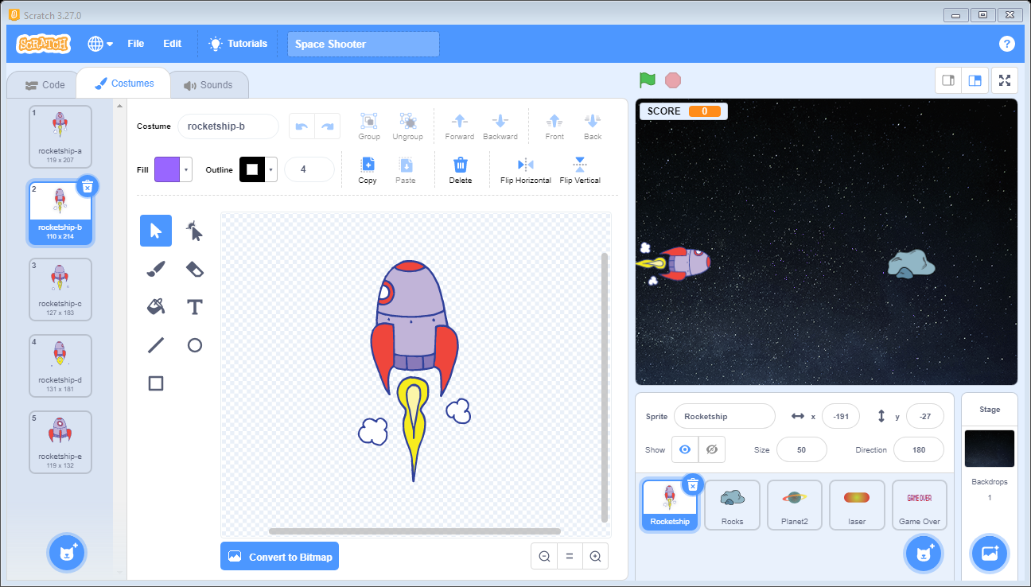 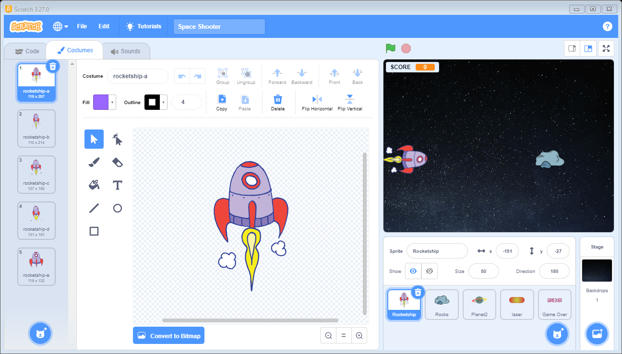

* Rocks

Rock is the second sprite used in Scratch Project. Its picture is given below:

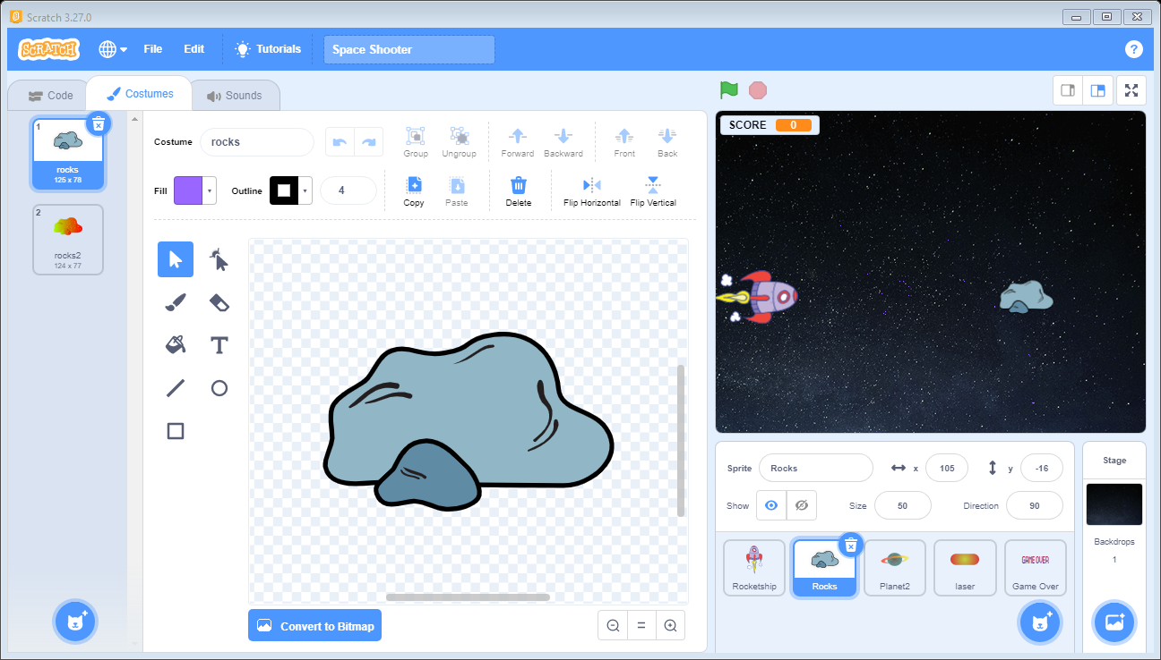

* Planet

Planet is the second sprite used inScratch Project. Its picture is given below:

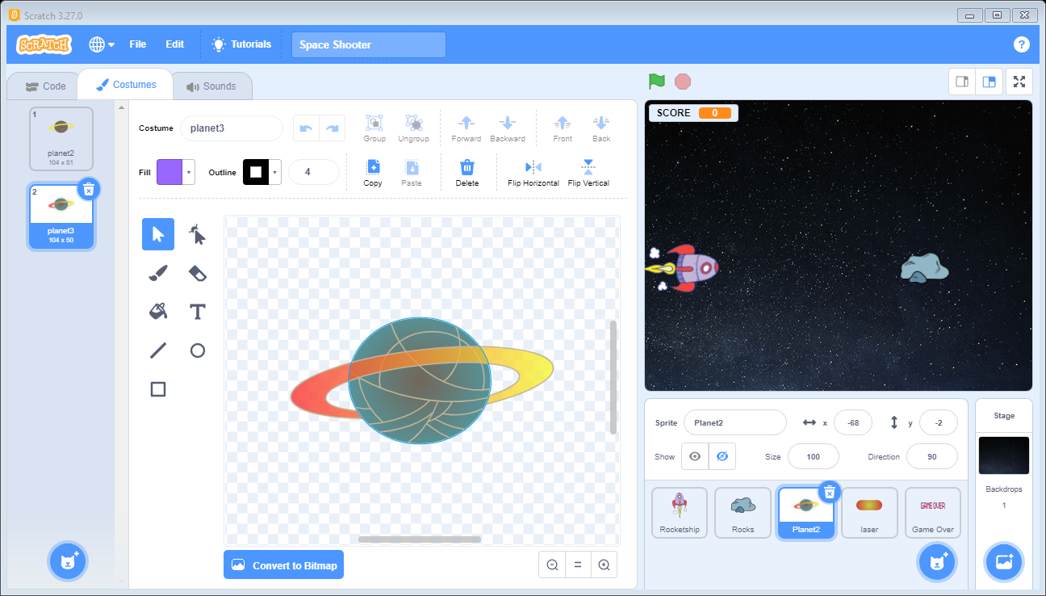

* Laser

Laser is the third sprite used inScratch Project. The spaceship shows this laser to destroy the rocks and planets. Its picture is given below:

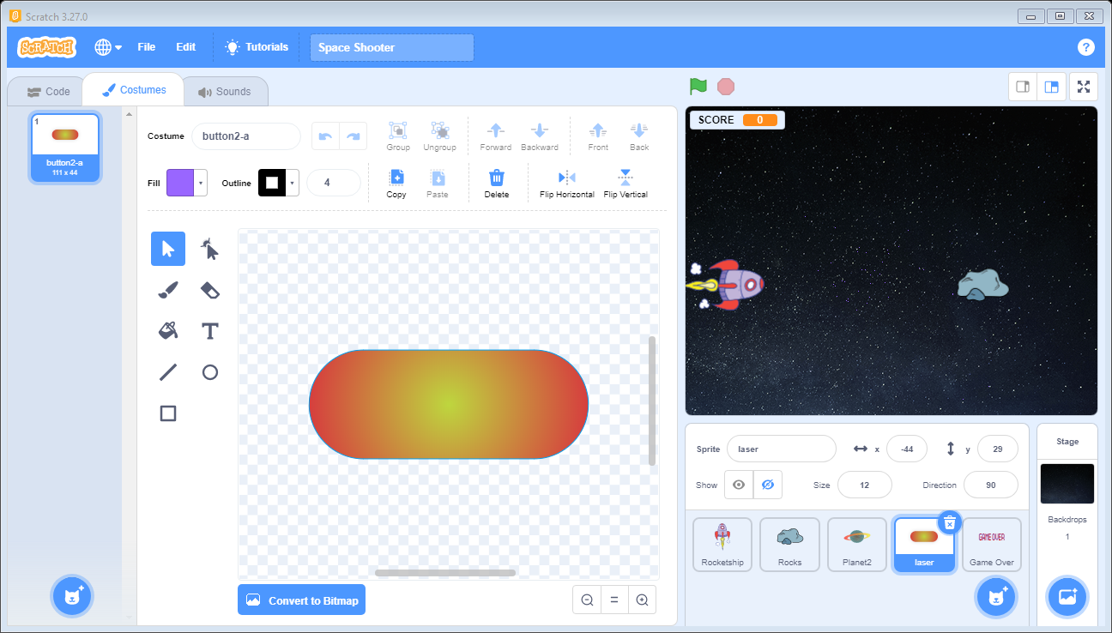

* Game Over

Game over is the third sprite used inScratch Project. It is only shown when the spaceship is touched with rocks or planets. Its picture is given below:

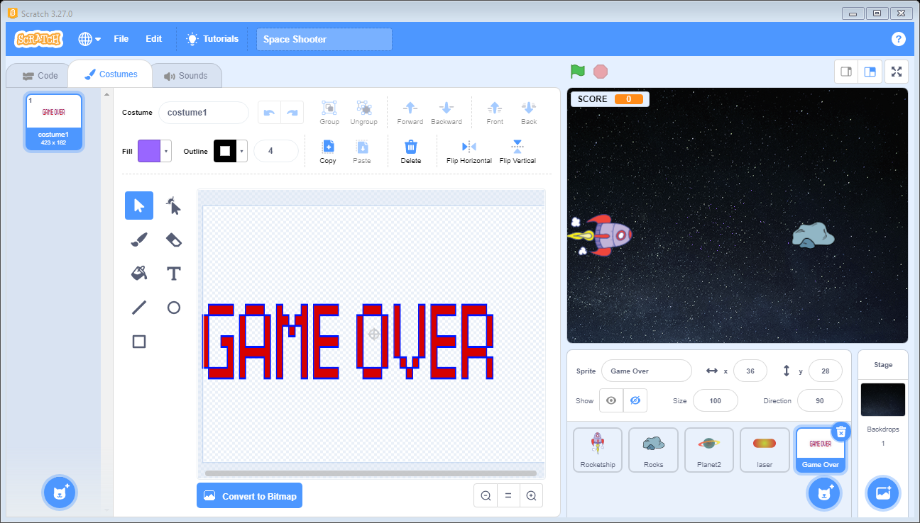

* Background

Background named “Stars” is used as the background on the Game.

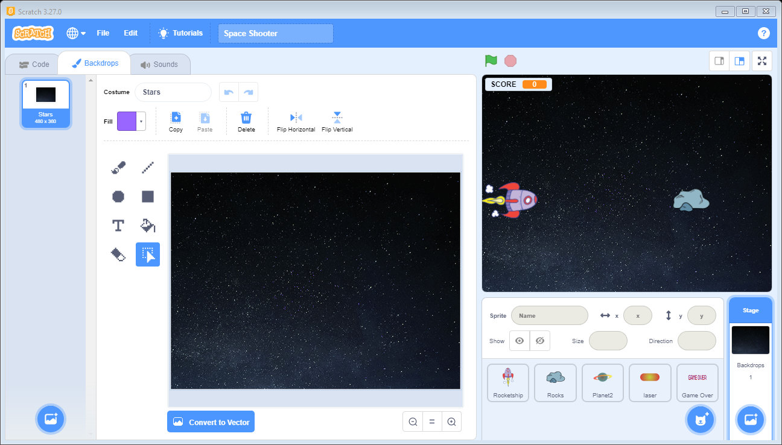

* Code

Everything running on the screen is due to code behind them.

There are some different types of control structures and operations are used in code. There are two variables used. 1 is Score which calculates the score of the game and the other one is used for the speed of sprites.

1. Code for Spaceship
2. Code for Rocks
3. Code for Planets
4. Code for Laser
5. Code for Game Over

* Startup

1. When user select the flag the game stats. The costumes of spaceships changes for 1s with a space sound.
2. A sound is starts as the background music in the game.
3. First only rocks will come and when the score limit reaches to 100 the planets also start to come with 2x speed.
4. When every laser hits the rock or planet a specific sound is played at the background.
5. The score variable calculates the score for the hitting the laser to rocks and planet.
6. Score for Rocks = 10 and the score for Planets = 20
7. The Starts as long the spaceship does not touch the rock or planet.
8. When the game is over the “Game Over” sprite is shown with the loose sound.